Washington Region
RFP Application: Project Overview & Budget
Request for Proposals: School-Community Partnerships – A Blueprint to Equitable Youth & Family Food Security
To apply for the RFP, submit this completed document to haley.x.ballenger@kp.org by end of day Friday, Sept. 9, 2022
Applicant Information

Community-based Organization (CBO) |  | School District
CBO Name: | Click or tap here to enter text. | District Name: | Click or tap here to enter text.
Project Lead Name: | Click or tap here to enter text. | Project Lead Name: | Click or tap here to enter text.
Title: | Click or tap here to enter text. | Title: | Click or tap here to enter text.
Email: | Click or tap here to enter text. | Email: | Click or tap here to enter text.
Phone Number: | Click or tap here to enter text. | Phone Number: | Click or tap here to enter text.
Address: | Click or tap here to enter text. | Address: | Click or tap here to enter text.
Website: | Click or tap here to enter text. | Website: | Click or tap here to enter text.
☐ By checking this box, I attest that I have the authority to apply for this funding on behalf of the above CBO. |  | ☐ By checking this box, I attest that I have the authority to apply for this funding on behalf of the above district.

Please verify your eligibility to apply (see RFP Section IV)

CBO Eligibility | District Eligibility
☐ Our CBO is or has a fiscal sponsor who is: a nonprofit 501(c)(3) tax-exempt organization, governmental entity, or tribal organization in good standing with IRS  Please identify: Click or tap here to enter text.  ☐ Our CBO is located within Kaiser Permanente Washington’s geographic service area of King, Kitsap, Pierce, Snohomish, Spokane, and Thurston counties  Please describe service area: Click or tap here to enter text.  ☐ Our CBO serves vulnerable population(s) within the District footprint (i.e. BIPOC, lowest income, etc.)  Please describe: Click or tap here to enter text.  ☐ Our CBO is led by a Board and Senior Leadership Team of at least 50% of individuals who identify as Black, Indigenous, and other people of color (BIPOC)  What percentage of your Board identifies as BIPOC? Click or tap here to enter text. %  What percentage of your Senior Leadership Team identifies as BIPOC? Click or tap here to enter text. %  ☐ Our CBO is trusted by the community, as evidenced by successful history of convening, gathering community input, and implementing community services and programs based on community need.  Please Describe: Click or tap here to enter text. | ☐ Our District is located within Kaiser Permanente Washington’s geographic service area of King, Kitsap, Pierce, Snohomish, Spokane, and Thurston counties  Please describe service area: Click or tap here to enter text.  Our District meets the following poverty indicators (check all that apply; must meet at least 2):  ☐ District-wide Free and Reduced Lunch (FRL) rate of 50% or higher  District-wide FRL Rate: Click or tap here to enter text. %  ☐ District-wide Black, Indigenous, and other People of Color (BIPOC) student population of 50% or higher  District % non-white population Click or tap here to enter text. %  ☐ District is mandated to operate Community Eligibility Provision (CEP) and/or Breakfast After the Bell (BAB) in a cluster of at least 5 schools or 33% of schools in district footprint (contact mvistica@uwkc.org for support w/ data analysis)  How many schools are CEP mandated? # or % or both Click or tap here to enter text.  How many schools are BAB mandated? # or % or both Click or tap here to enter text.  ☐ We plan to develop our project with Child Nutrition Services & Community/Family Engagement District Departments (description requested in project overview)

Grant Project Overview (See RFP Sections I-II & V-VII)
Projects awarded must have the following objectives:
- Foundational activities (gray box) improved to “mostly” or “fully” in place by end of grant term
- At least one tiered intervention (colored layers in the blueprint pyramid) is implemented
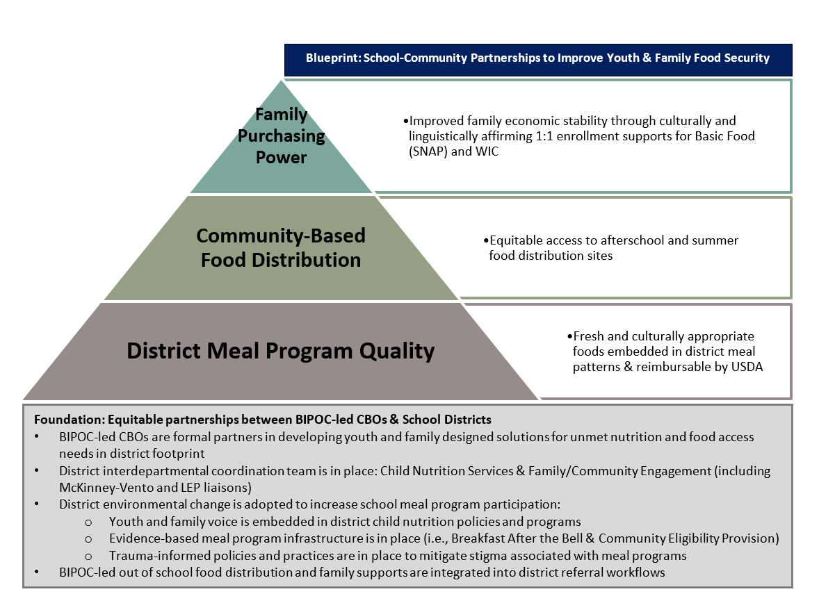
- Engage in KP’s grantee learning cohort, designed to explore improvements and recommended practices for equitable partnerships between BIPOC-led CBO and schools for replication in other communities
Project Description
Please fill in the below. Though phase 1 of the grant term will be dedicated to developing an action plan, we would like to understand interest areas, community needs, and the community strengths in place to set your project up for success.
- Describe the food access needs in your community, and the population(s) you intend to serve with this project. Note: | Click or tap here to enter text.
- Describe your partnership vision:  - Do you have a history of working together? Please describe. (this is not a requirement)  - Which assets and expertise will each partner bring to the project?  - How will your partnership be structured to set the project up for success and assure accountability to required deliverables? | Click or tap here to enter text.
- (District Question): Describe the Child Nutrition Services school, afterschool, and summer meal programs in place in your district. Describe any additional programs you plan to implement in the coming two school years. Note: Districts who plan to implement Community Eligibility Provision and/or Breakfast After the Bell in the maximum number of schools possible by SY 22-23 will be prioritized. See “Grouping” on pg 15 or contact mvistica@uwkc.org for technical assistance and data/eligibility analysis. | Click or tap here to enter text.
- Describe any additional elements of KP’s Blueprint Model that are in place already in each partner’s work. (this is not a requirement) | Click or tap here to enter text.
- At this time, how do you envision improving Blueprint model foundational activities (gray box) to “mostly” or “fully” in place by the end of the grant term? Note: this is a grant requirement. | Click or tap here to enter text.
- Based on what you know about community needs, assets, and opportunities; which tiered intervention(s) from the Blueprint Model do you anticipate addressing through your project? Please check all that apply and describe any ideas you have at this stage. Note: at least 1 is required. Please be realistic with what is feasible during the grant term. The following types of projects will be prioritized:  - Serves schools with 50% and higher Free and Reduced Lunch rates and/or 50% and higher student of color population  - Demonstrates innovation for equity  - Incorporates systems and programs that sustain meal distribution beyond the grant period | ☐ Tier 1: District Program Meal Quality (Fresh and culturally appropriate foods embedded in district meal patterns and reimbursable by USDA)  ☐ Tier 2: Community-Based Food Distribution (Equitable access to afterschool and summer meal distribution sites)  ☐ Tier 3: Family Purchasing Power (Improved family economic stability through culturally and linguistically affirming 1:1 enrollment supports for Basic Food (SNAP) and WIC  Description of ideas:  Click or tap here to enter text.
- (District Question): Which district departments do you plan to involve in the planning and implementation of this project? How will you coordinate to ensure the project is successful? Note: applicants demonstrating interdepartmental collaboration with Child Nutrition Services and Family/Community Engagement (including McKinney-Vento and LEP liaisons); or who have a plan for collaboration if not already taking place, will be prioritized. | Click or tap here to enter text.
- Project Budget: Specify the amount you will be requesting from Kaiser Permanente and describe anticipated budget line items (see RFP Sections III & VI for instructions and example equitable scenarios). Notes:  - It is expected that each partner is allocated equitable funding to support staffing and other operating costs that assure project success (see Section VI)  - Each partner must have a dedicated PM who will be accountable to meet deliverables in Section V. A minimum of 1.0 FTE split between partners (i.e. 0.5 FTE for CBO and 0.5 FTE for District) is required. 1.5 FTE is recommended. It is acceptable for PMs to be hired during phase 1 of the grant  - Finalists will be asked to provide a detailed budget with clear line items for Planning Phase + estimated costs for Implementation & Integration Phases. (Within the grant term, a revised budget is submitted @ end of Planning Phase) | CBO Request District Request  Total request over 3 years $ Click or tap here to enter text. Total request over 3 years $ Click or tap here to enter text.  Anticipated line items Click or tap here to enter text. Anticipated line items Click or tap here to enter text.  % FTE for dedicated CBO project manager (i.e. 1.0 FTE) Click or tap here to enter text. % FTE for dedicated district project manager (i.e. 1.0 FTE) Click or tap here to enter text.  CBO project manager: ☐ is in place ☐ will be hired in phase 1 of grant District project manager: ☐ is in place ☐ will be hired in phase 1 of grant
- Budget Narrative: Describe any ideas or plans you have for leveraging other funding opportunities to support project sustainability. Note, project budgets that identify and fill in gaps not addressed by federal and state funding will be prioritized. See RFP Section VI for ideas. | Click or tap here to enter text.
- (Optional) Is there anything else you’d like Kaiser Permanente to know?  Questions? Contact haley.x.ballenger@kp.org | Click or tap here to enter text.

